|  |  |  |
| --- | --- | --- |
| SCHOOL OF INFORMATION AND TECHNOLOGY | | |
| NAME: Charles Hanzel D. Gerardo | DATE PERFORMED: 09/12/2003 |  |
| Section: IDC2 | DATE SUBMITTED: 09/12/2003 |

# SYSADM1 – Managing Services in Linux

# Requirement:

* A virtual machine running Linux

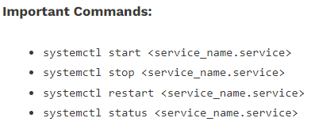

Complete this lab as follows:

Use the service –status-all command to list all active and inactive services.

List down active and inactive services in the table below. Provide five (5) services for each column.

|  |  |
| --- | --- |
| **Active** | **Inactive** |
| plymouth-log | plymouth |
| cups | cryptdisks |
| dbus | cryptdisks-early |
| ufw | saned |
| openvpn | whoopsie |

SS:  
  
  
  
  
  
  
  
  
  
  


Start the Bluetooth service using the systemctl command.

Ex. sudo systemctl start httpd



Check the status of the Bluetooth service. What is its status?  
The status of the Bluetooth service is closed or off. It is indicated through the symbol on the left of the “bluetooth.service – Bluetooth service” on the 2nd line on the picture. It is also indicated through the words on the right side of the “Active:” which says “inactive (dead)” meaning it is close or off.

SS:  
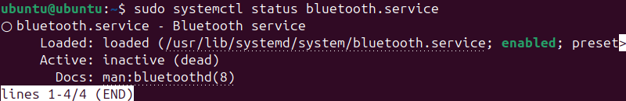

Check the status of the cups services. Since when was it running?  
The cups.service has been active and running since the operating system has been installed, there are list of active services when first checked and cup.service is one of them. In conclusion, cups.service hasn’t been modified or activated, it was active all along.

SS:  
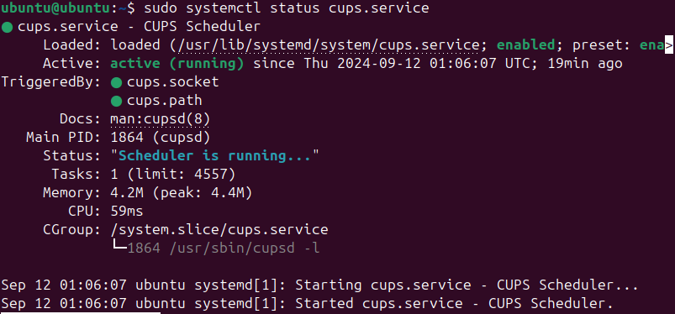

Stop cups services. 

Verify if the service was stopped.   
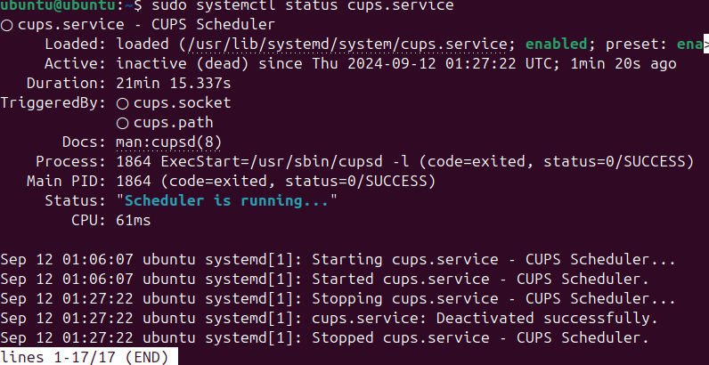

Restart the cups services  


Verify if the service was restarted.   
